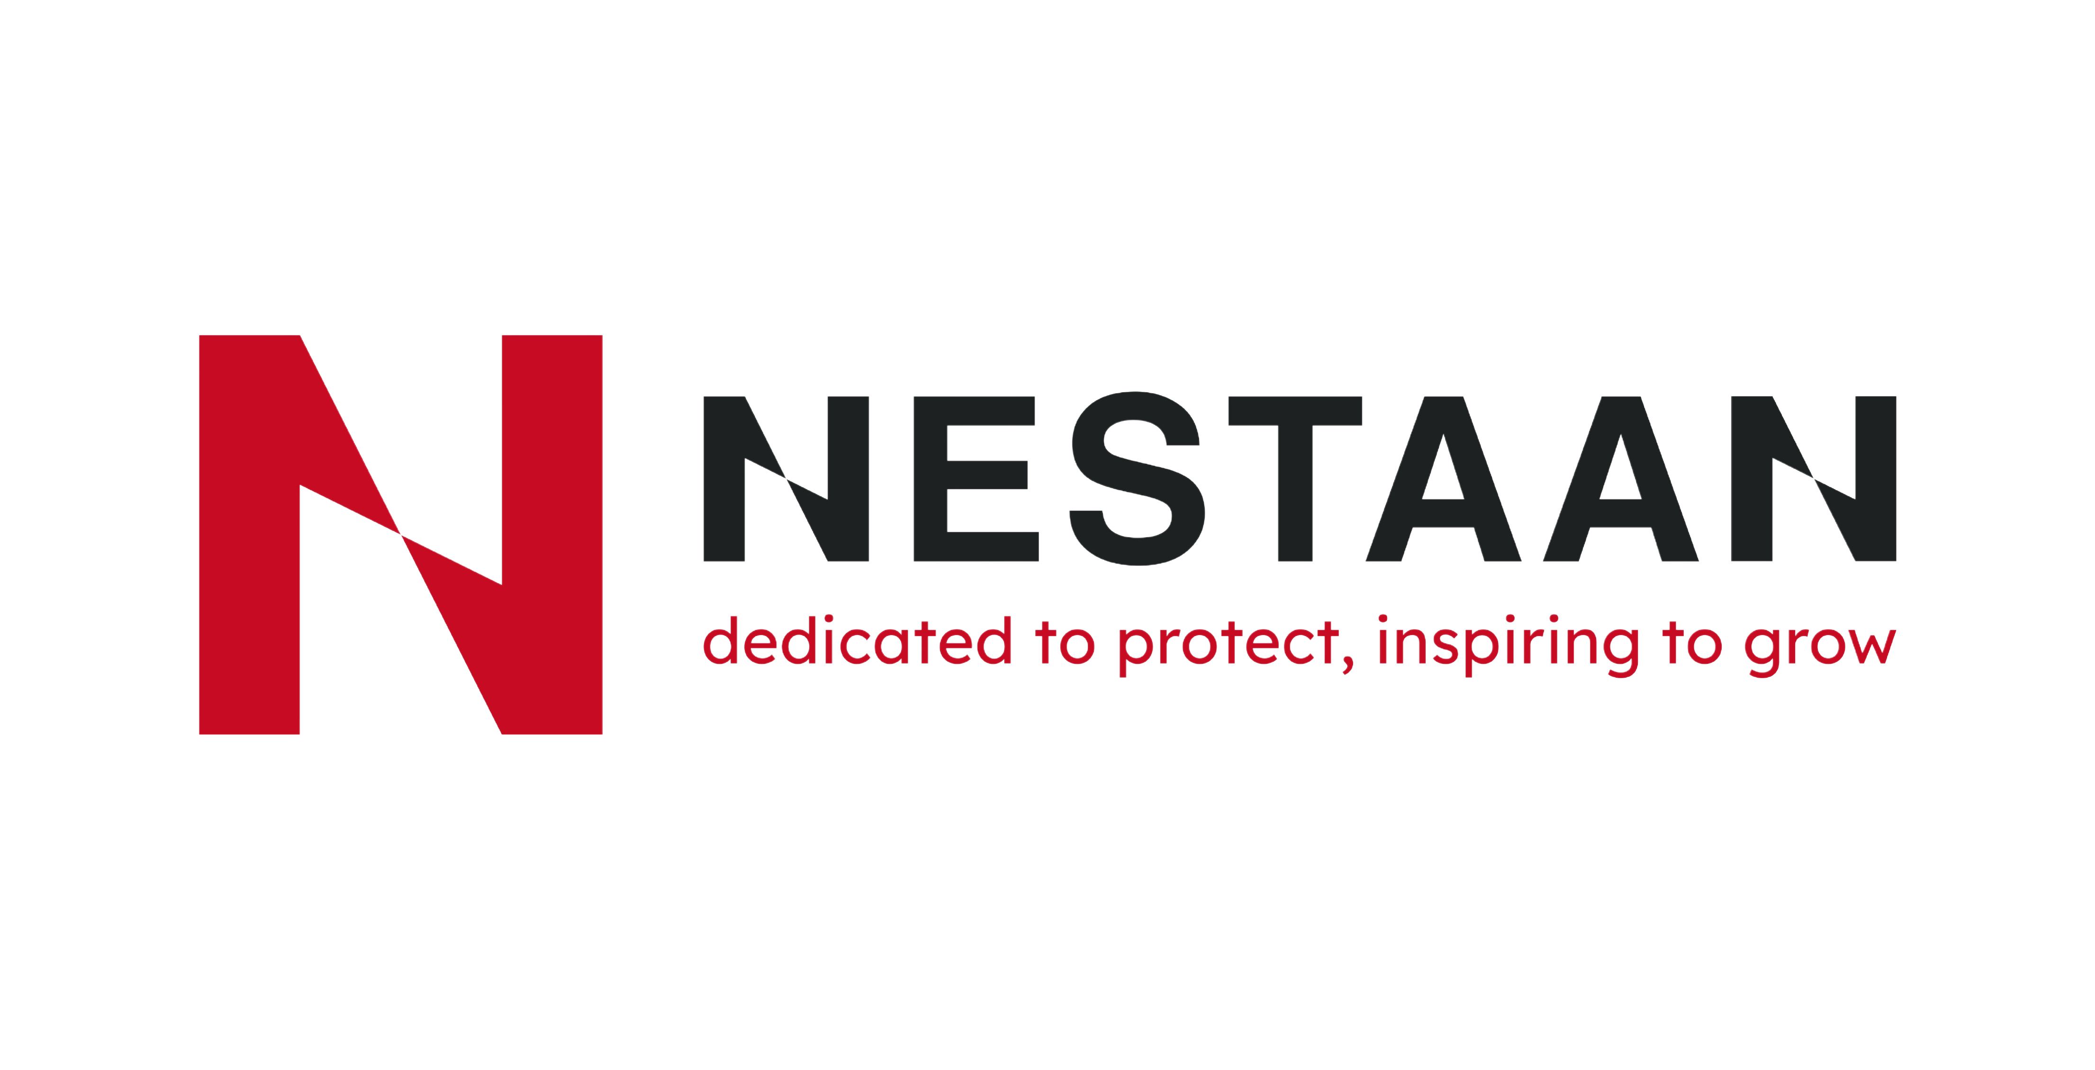 PRODUCT INFORMATION

LIMPET BD-6

Self-setting cement

- DESCRIPTION

A self-setting cement for internal, external and marine use as a protective layer over calcium silicate and all mineral wool insulations. The product is supplied in dry form for mixing with clean water on site, and, when set, give a tough surface suitable for painting. Manufactured from selected cementitious binders, inorganic fillers and other reinforcements. It does not require heat for setting but is not impervious to water and hence should be protected by a flexible weatherproof coating for all external applications.
The product is asbestos free.

- DENSITY

Nominal average dry density: +/-1200 kg/m³

- THEORETICAL COVERAGE

 | m²/tonne
Limpet BD-6 | 248 at 3 mm thickness
 | 124 at 6 mm thickness

- FIRE PERFORMANCE

The product is rated “non-combustible” to BS 476 Part 4 : 1970. They comply with the performance requirements of Class “O” as defined in the Building Regulations.

- TEMPERATURE LIMITATION

Limpet BD-6: 175 °C

- THERMAL CONDUCTIVITY

Finishing composition is not specifically manufactured as thermal insulation, but where it is required to know the thermal resistance for calculation purposes, the following values should be used :

Thickness (mm) | Thermal Conductivity  (W/mK) | Thermal Resistance  (m²K/W)
3 | 0,2 | 0,015
6 | 0,2 | 0,030
12 | 0,2 | 0,060

- STANDARDS

The product is conform to BS 3958 : Thermal Insulating Materials, Part 6 Finishing materials,
hardsetting composition, self-setting cement and gypsum plaster.
For additional application information refer to :
BS 5422 : 1990 : Method for specifying thermal insulating materials on pipes, ductwork and equipment.
BS 5970 : 1992 : Code of practice for thermal insulation of pipework and equipment.

- SHELF LIFE

Dry stored : 12 months

- PACKAGING

BD 6 is supplied in white printed PE bags of 25 kilo,
40 bags/pallet.
Heat Treated pallets with ISPM mark of 1,20 x 1 m
Pallets are foiled with stretch foil

- TECHNICAL ADVICE

A technical advisory service is available to discuss any potential application of our products.
Please contact +32(0)69 77 83 20 Nestaan NV in Belgium .
Versie
25.01.2024

Guarantee and liability: Nestaan NV guarantees that her products, within their shelf life, maintain their properties within the tolerances as indicated in the specification. Our liability will never exceed what is indicated within our general conditions of sale, which can be obtained upon request and which are indicated at the back side of our offers, order confirmations and invoices. By no means the seller is liable to any consequential damages whatsoever. The provided information is the result of our testing and experience and is of general nature. This information by no means implements any acceptance of liability. It is the responsibility of the user, by his own testing, to evaluate if the product is suitable for its intended application. The information and recommendations in this publication are, to the best of our knowledge, accurate at the date of publication. Nothing herein is to be construed as a warranty, whether expressed or implied. In all cases, it is the responsibility of users to determine the applicability of such information or the suitability of any products of their own particular purpose.
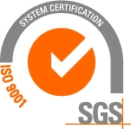

PRODUCER:

Nestaan NV ZI Tournai Ouest II Rue du Bois des Hospices 2 7522 Blandain

Tel : +32.69.77.83.20 Fax : +32.69.22.95.27 infonestaan@nhb.be

